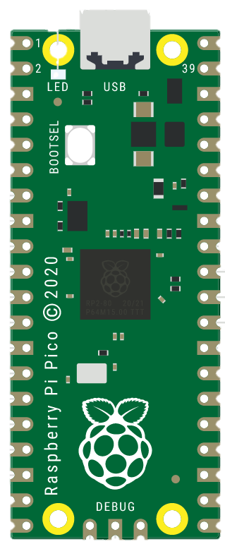­­

­­

**Made By:**

**Sarang Rajesh Sakhare**

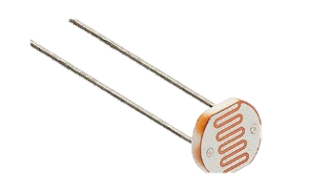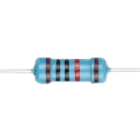

3.3 V

10k Ω Resistor

LDR

GND

GPIO 26

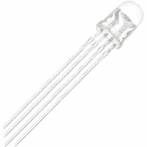 ­

Input RGB LED

(Common Cathode)

+3.3 V (GREEN)

+3.3 V (BLUE)

+3.3 V (RED)